|  |  |
| --- | --- |
|  |  |
|  | [MyBlogs]  Web Design Document |
|  | [05/21/2018] |

Preface

|  |  |
| --- | --- |
|  |  |
| Current Version  1.0.0.0 |  |
| Owner  Brijesh Subhagan |  |
| Date Last Updated |  |
| Last Updated by |  |
| Author  Brijesh Subhagan |  |
| Date Created  05/21/2018 |  |
| Approved By |  |
| Approved Date |  |

Revision History

|  |  |  |  |
| --- | --- | --- | --- |
| Version Number | Date Updated | Revision Author | Brief description of changes |
| 1.0 | 04/21/2018 | Brijesh Subhagan | Initial draft. |
|  |  |  |  |
|  |  |  |  |
|  |  |  |  |
|  |  |  |  |
|  |  |  |  |
|  |  |  |  |
|  |  |  |  |
|  |  |  |  |
|  |  |  |  |
|  |  |  |  |
|  |  |  |  |

Contents

1. Introduction 1-1

Requirement 1-1

Technologies Used 1-1

Angular Components Used 1-1

1. Home Component 1-1

2. Navmenu component 1-2

3. UserManagement component 1-2

4. Blog Card Component 1-3

5. Blog Create Component 1-3

6. Blog Component 1-4

7. Comment-box Component 1-4

8. Registration Component 1-5

9. Login Component 1-5

**Note:** The above table of contents is automatically created from text that is styled with Heading 1, Heading 2 and Heading 3 in the following pages (right-click on the table and select “Update Field”).

# Introduction

## Requirement

Create a simple blog application that allows only authenticated users to add a new post. There will be 2 levels of authorization in the web application a “Standard User” and an “Admin User”. Each user will have access to separate parts of the application and can perform different tasks.

Key Functionalities:

1. A user can register in the web application.

2. A user can login to the application.

3. A signed in user can create a new blog post.

4. Public users can view any post and leave a comment on the post.

5. A blog post can have many comments.

6. An admin user can delete a post.

7. An admin user can delete a Standard User and not an Admin User.

8. An admin user can give admin permissions to another user.

## Technologies Used

|  |  |
| --- | --- |
| **Backend** | **Sql Server with Entity Framework, ADO.Net** |
| **Front End** | **Angular 4** |
| **Server side** | **WebAPI** |
| **Framework** | **Asp.Net Core** |

### Angular Components Used

### Home Component

This component is responsible for dynamic population of all the posts. Admin user should have the option to delete each post.

Please find the attached screenshot below:-

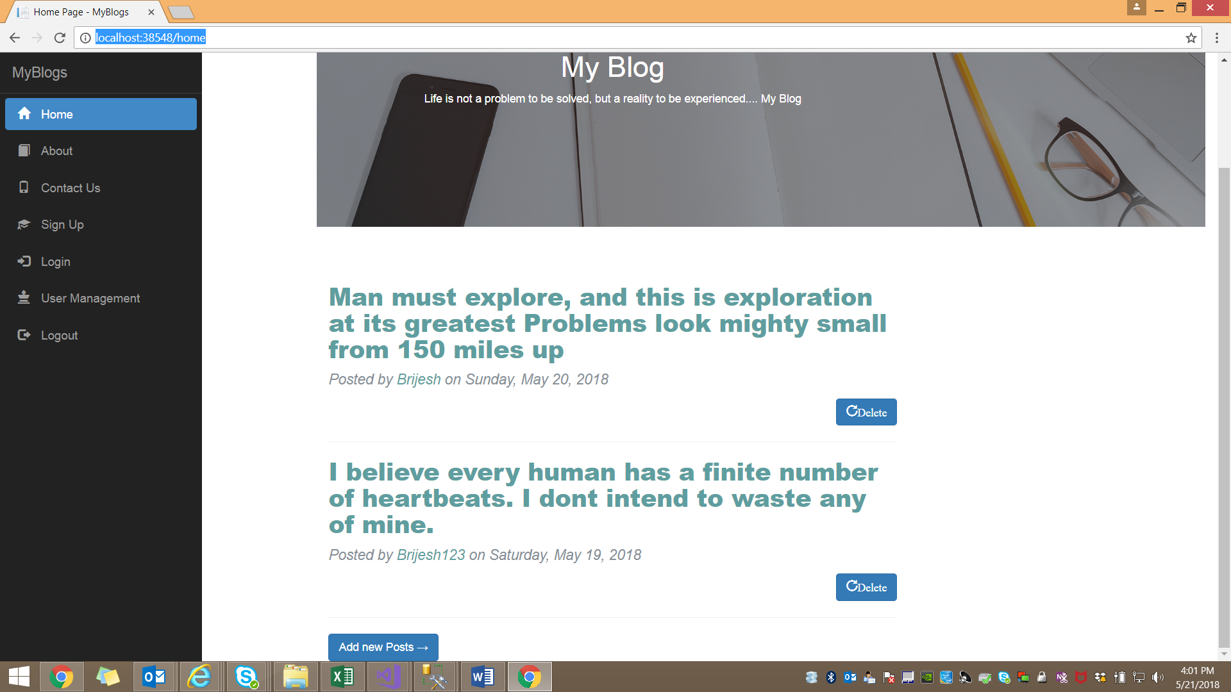

### Navmenu component

This component is responsible for the population of menu item. Admin user should have the option to see the usermanagement as well.

Please find the attached screenshot below:-



### UserManagement component

Admin user can view the list of all users. Admin user can assign the admin role to other user as well.

Please find the attached screenshot below:-

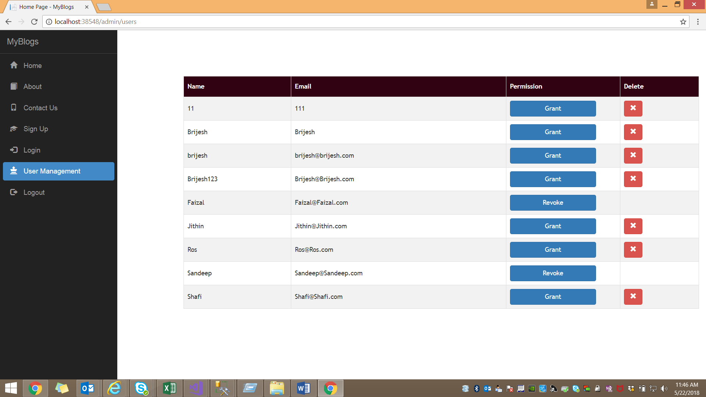

### Blog Card Component

Using this component in home component to display individual blogs. If the user clicks on the blog title then display full details

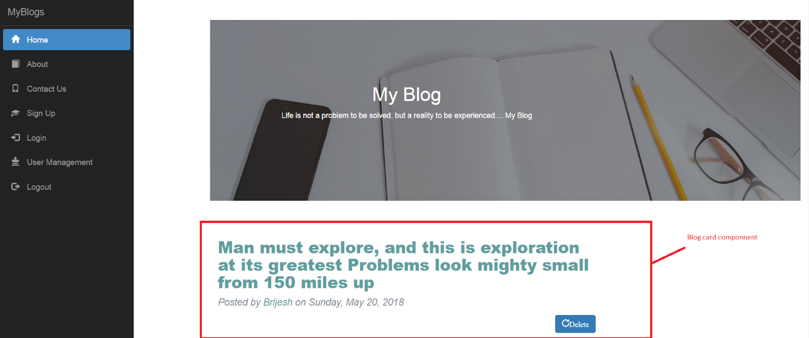

### Blog Create Component

This component will display when the user clicks on the Add posts in home component. We can enter post title and post body in this component.

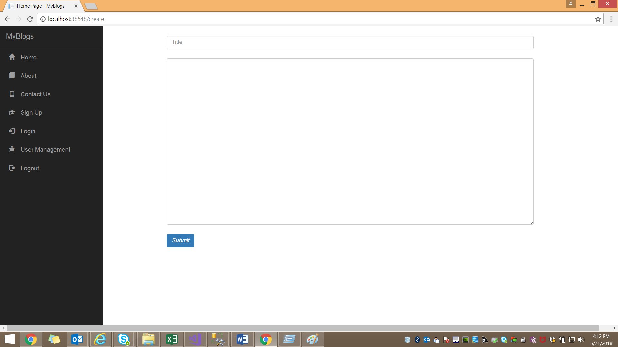

### Blog Component

This component will display the post details.

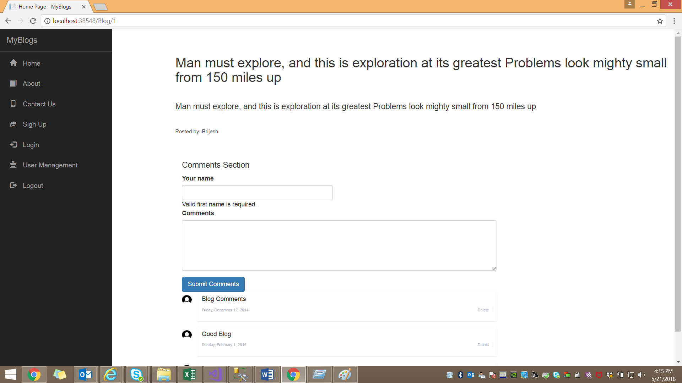

### Comment-box Component

This component will display all the comments.

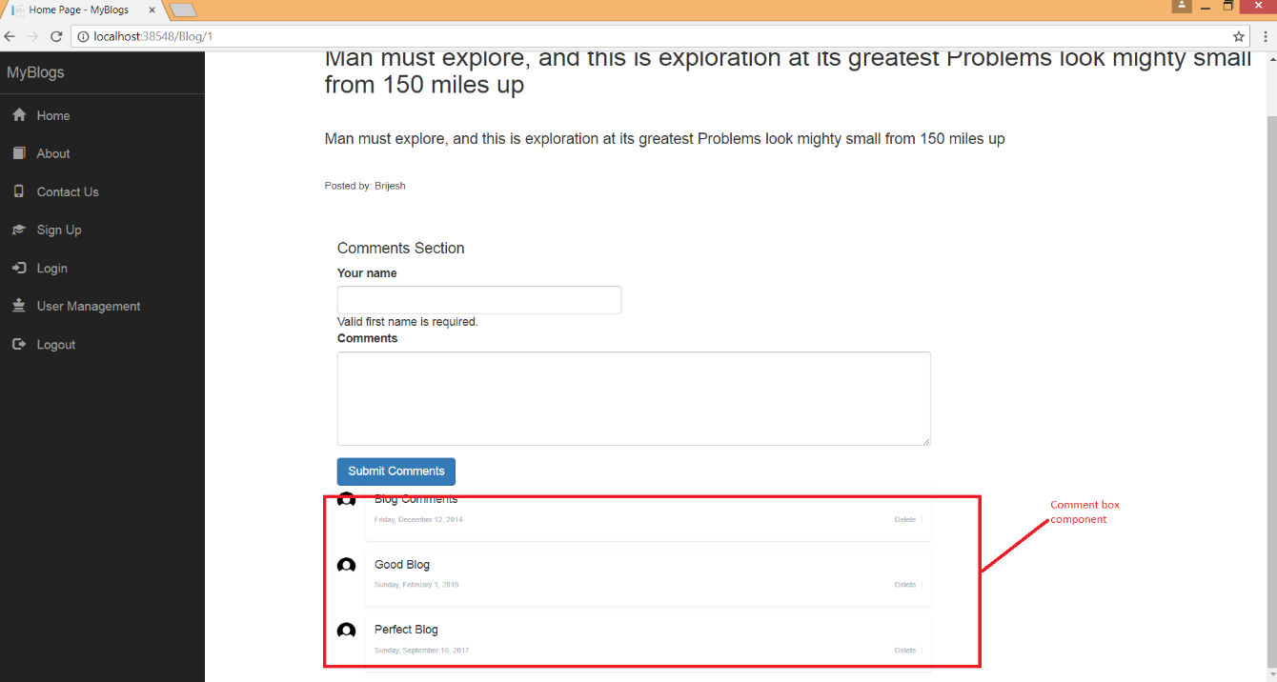

### Registration Component

With this component we can register in this site.

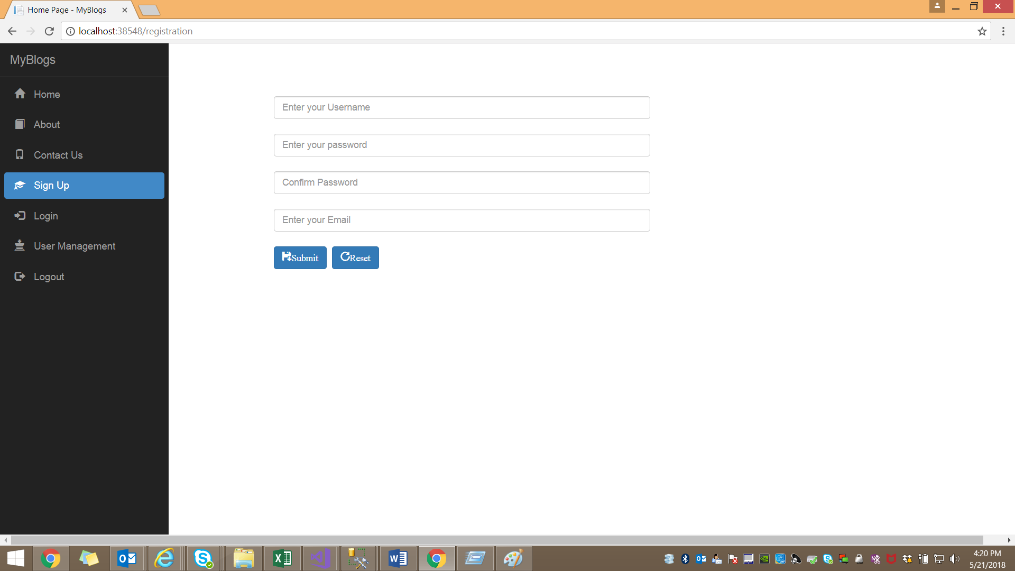

### Login Component

This component will have the fields to enter the credentials.

